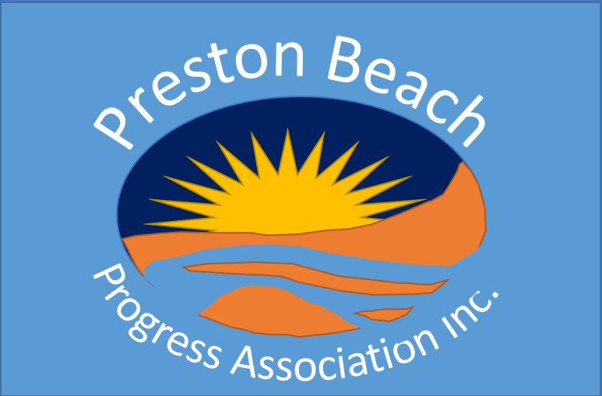
Preston Beach Progress Association Inc
14 Panorama Drive
PRESTON BEACH WA 6215
ABN 85 602 737 617

info.pbprogress@gmail.com

Preston Beach Progress Association Inc – Reg No 1003134

MINUTES OF THE GENERAL MEETING of the Preston Beach Progress Association Inc. held at the Community Hall on Saturday 03 August 2024 commencing at 10:00am.

Appointment of Chair for AGM: Lyn notified the membership that Vicki Bosworth had advised that she could not attend the meeting due to clashing events. Lyn Allen proposed that Bob Goodwin be appointed to Chair the meeting.

PRESENT: Lyn Allen (Treasurer), Bob Goodwin (Secretary), Peter Eastlake, Dan Norton, Jenny Arthurson, Gillian McSwain, John McSwain, Noel Dew, Mick Farragher, Marion Herkes, Robyn Clarke (MLA), Charlie Clarke (Councillor), Peter Allen, June Boardman, Georgie Tunstill, David Shopland, Bill Russell, Di Batey, Charlie Batey, Mike Cardy, Ben Rose (Shire of Waroona).

APOLOGIES: Vicki Bosworth (VP), Mark Bosworth, Nola Eastlake, Irene Dew, Robin Cardy, T Orrell, F Everly, Jill Norton, Don Bebbington, Jan Bebbington, Martin Royce, Sue Royce, Romilly Goodwin, Craig Logan, Michelle Logan, Deb Tyler, Rick Madin, Jocelyn Madin.

QUORUM: (min10) – 21 attendees: A quorum was declared, and the meeting proceeded.

MINUTES OF THE PREVIOUS GENERAL MEETING: The minutes of the previous GM held on the 04 May 2024 were circulated electronically on 06 May. Dan Norton Moved that the minutes be accepted as a true record of that meeting and Marion Herkes Seconded. The motion was Carried.

WELCOME: by Bob Goodwin. The PBPA is now 40 years old and all those people involved over the past years should be congratulated for their success in building the strong organization that exists today. Some “From the Archive” information is being added to the weekly updates that reflect important and interesting things that have happened over the last 40 years.

APPROVAL OF NEW MEMBERS

First Name | Last Name
Cindy | Beynon
Jenny | Hood
Trevor | Hood
Courtney | McBarron
Francesca | McBarron
Lorraine | Waits
Philip | Waits

Jenny Arthurson moved to approve the new members and Di Batey seconded and all approved. The motion was carried.

SECRETARY’S REPORT
Secretary Stuff Done
- The work to consolidate electronic files from various sources into a single structured filing system is mostly done. Drop Box files have been reincorporated into the main filing system. A pile of old CDs were reviewed (mostly photos and videos). The photos have been combined back into the main filing system and the videos have been kept in CD format.
- The hard-copy files stored in the back storeroom have all been reviewed and consolidated. Correspondence, minutes and newsletters have been reviewed and filed in date order. They have been divided between what we want to keep and what we want to destroy. A quote was received to scan and digitize them (particularly the correspondence and minutes) but we deemed this too expensive (>$1,100), so they will be scanned by ourselves over a period of time or kept in hard copy (much reduced in volume).
- Weekly updates continue to be issued.
- The Newsletter to members and sponsors was issued for Qtr 2 (with the help of Melinda Samways) in electronic format. The Qtr 3 newsletter was shortened and issued by letter-drop to the whole town and to members by email. The response to the shortened format was generally positive.
- A second combined Events Calendar meeting was held with the Golf Club and the Community Garden. A new events calendar has been developed.
- We have now got a Grants Connect password and are reading the grants available.

Secretary Stuff Still to Do
- The 2025 PB Calendar is being assembled. Melinda Samways is assisting (many thanks).
- The list of sponsors and service providers still needs to be updated.

The Lake Trail
This trail was initiated by PBPA in 1998 and finished in 2003. It is included on Yalgorup Lakes National Park list of trails. It was funded by a grant and one of the grant conditions was that “The PBPA has undertaken sponsorship and on-going support and maintenance of the Trail through “Friends of the Trail”…. The “Friends of the Trail” group will monitor usage and condition and assist in the maintenance.”

Some good elves have recently been cleaning up the Lake Trail (Totem Poles to the Lake) after its condition was raised at the last PBPA GM. I am suggesting that we officially re-form a “Friends of the Trail” group. Duties of the “Friends” would be:
- Walk the trail once a month (no we won’t be counting).
- Pick up any man-made refuse and put it in a bin (home or elsewhere).
- Throw any natural refuse (ie: sticks, etc) off the path and into the bush.
- Send PBPA an email if there is anything too big to do easily yourself.

This group and these actions should help keep the trail in an attractive, useable condition. It is currently used by quite a lot of dog walkers each day. This proposal was agreed by the meeting and the following people agreed to join the “Friends of the Trail”:
- Jenny Arthurson
- Marion Herkes
- June Boardman
- Dave Shopland
- John and Gillian McSwain
- Mick Farragher
- Bob and Romilly Goodwin

This information will be publicised in a weekly update and other members invited to join. Jenny Arthurson suggested that the trail be extended to join the walk down from the 4th golf green at the top of Panorama Drive. Bob Goodwin suggested that we go and have a look at this route and review.

Shire Strategy Day
A Strategy Day was held by the Shire’s Development Team at the Community Centre on 15 June. This was combined with a ‘learn to paint landscapes’ activity and ‘bush tucker’ demonstration. Ideas were collected by Post-it notes under various themes. Ideas posted by PB residents included the following:

Showcased
Upgrade / install a Welcome sign.
Get a tourist Caravan Park
Build a road to Myalup on the west side of Lake Preston – 2nd means of egress
Empowered
Enclosed / gazetted dog park
Healthy
Get scheme water to replace bores
Outdoor gym equipment
Refresh walkways
Older exercise classes / less intense
Safe
Traffic calming on Panorama Dr and Waterway Rd – footpaths - safety of pedestrians
Repair stairs on Fairway Cresent
Engaged
Consistent communication from Shire
The beach sign opposite the shop is decayed and should be relocated to the beach
A welcome noticeboard with info the changes – PBPA can arrange info
Re-purpose the Ranger outpost
Refresh the walkways that are gazetted between streets
Create an increased social calendar
Refresh and promote the Yalgorup Lakes walk trails
Shire to attend PBPA General Meetings
Make footpaths wide enough for golf carts

These ideas will be distributed to members to gauge the level of interest in each item.

Shire Works
The Shire had completed the new Beach Access Improvement works and the speed humps going down Mitchell Road to the beach. These improvements were appreciated, but members believed that the speed humps had little effect of large 4WDs. Some members requested speed humps going up Mitchell Road from the causeway. This will be put to the Shire.

Population Statistics
Information provided by the Shire on the Strategy Day included the following table:
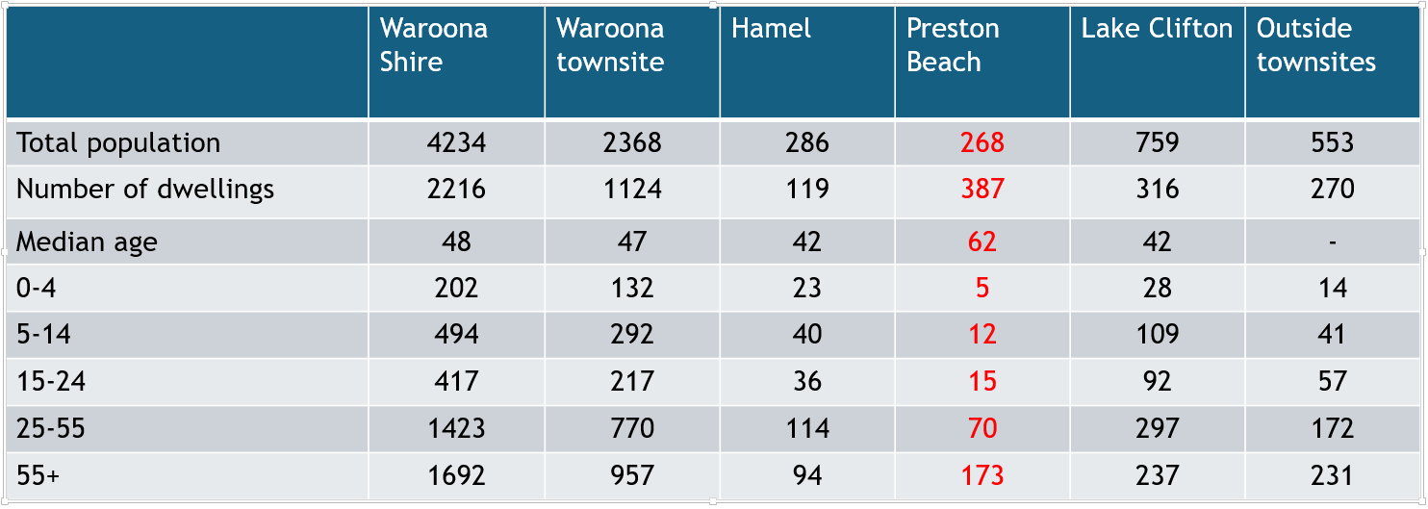

Noticeably, PB has a much older median age (by around 20 years) than the other Waroona townsites. This needs to be remembered by both PBPA and the Shire when proposing works and activities. It is noticeable however that with the recent building boom and sales of dwellings there are now more letter boxes appearing in PB. This infers that more people may be starting to live here. This might start to lower the median age.

Gazetted Dog Area
Whilst PB has a gazette dog area (see below map):
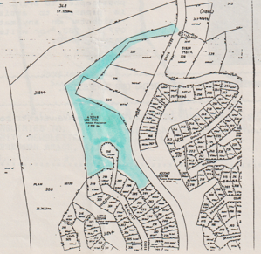
This area is basically useless for its intended purpose

Rick Madin wrote a letter to PBPA requesting support to approach the Shire to turn the old, fenced tuart compound adjacent to the 5th fairway into a dog exercise area. The area under discussion is shown below:
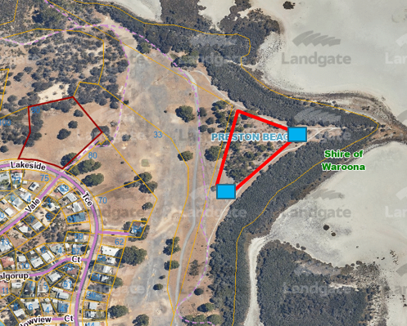
After some discussion regarding the history of the area and other options that had been considered, it was agreed that the PBPA would progress the proposal. The proposal would require a grant to cover the cost of the following:
- Reinstalling the gates.
- Signage
- Clearing the area of dead wattle trees and weeds.
Robyn Clarke suggested applying for a grant in advance of negotiating with the Shire over gazetting the area, since the funds could be returned if the Shire could not be persuaded to gazette it.

The PBPA did not agree with the idea of a road / track crossing the 5th fairway to the compound. Any cars would need to park on the western side of the fairway and dog owners would then need to walk to the compound.

The PBPA will now form a small committee to advance this issue and add it to its list of items to discuss with the Shire.

Doyle’s Quarry
The EPA has been in contact with FRAGYLE’s Hilary Wheater regarding an upcoming meeting in late August at Lake Clifton. Hilary (overseas) has in turn been in contact with various FRAGYLE members and asked if Bill Russell could represent FRAGYLE. The email correspondence will be sent to Bill for review.

To refresh everyone’s memories, Doyles Quarry is a proposed limestone quarry to the north of PB along the Martin’s Tank road and located as shown on the map below:
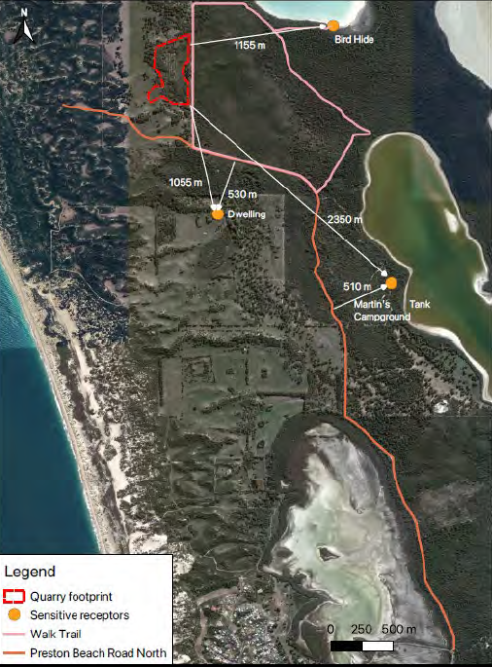
It requires the use of the Martin’s Tank Road (ie: Preston Beach North Rd) to get onto the Preston Beach Road and out to Forrest Hwy. In 2022, many PB residents made electronic submissions to the EPA regarding their concerns about this operation. Nothing further had been heard until now.

Robyn Clarke advised that there were many issues with regards to Preston Beach North Road that would need to be addressed if this quarry operation was to proceed. This would require large amounts of funding from the proponents. Robyn would follow up about why this upcoming meeting had been called.

CORRESPONDENCE:
A formal letter was sent to the Shire of Waroona CEO after the previous GM. This included:
- Whether PBPA could promote installation of a Welcome sign / noticeboard close to where you exist the causeway. This could potentially include a map of PB showing whereabouts of facilities. The Shire supplied their Style Guide regarding signs, but after reviewing old correspondence, there is a long history to this. This requires further review and discussions with the Shire.
- The Shire agreed that we could put up a map of PB inside the Community Hall. Lyn has now sourced one, so we will get it framed and mounted.
- The Shire is awaiting budget approval before any action is taken on the approved ‘Preston Beach Management Plan’. The PBPA Committee intend to seek a meeting with the Shire CEO during Qtr 4 on this and various other matters regarding corresponding with PB residents.
- The Shire responded to our query on proposed changes to property laws as follows:
  - The Local Government Property and Public Places Local Law still has not made its way to council, but when it does that … will be going out for community consultation.
- The discussion of the ‘Community Car’ (from the last GM) was referred to the Waroona Community Resource Centre. I am yet to make contact.
- The Shire supplied the requested copies of the PB Foreshore Mgmt Plan (2021 & 2001) (now read).
- Various government departments’ correspondence received has been circulated to members via weekly updates.
- Email correspondence has been sent to the Waroona Shire regarding the state of environmental signage at the lake viewing platform. Charlie advised that the Shire will replace them.
- An email request was received requesting PBPA contact Main Roads with regards to the fuel signs at the turn-off. These have now been actioned by Main Roads.
- An email request was received regarding whether PBPA could extend volunteer help to people who might need medical appointment (type) assistance. Only one person replied to this in the affirmative, so this is not something that the PBPA will pursue further.
- The discussion regarding more general use of the Community Hall meeting room was met with general approval. To date however, there has been limited concrete proposals regarding alternative uses. Jenny Hood has since commenced providing a commercial physiotherapy service from this room, but this did not require any modification to the room (eg: removal of carpet). Until we receive other more detailed proposals, we do not intend to advance the relatively expensive refit of this room.

VICE PRESIDENT’S REPORT:
The PBPA will be seeking a meeting with the Shire during Quarter 4 to discuss various issues related to the PBPA and communications with the Shire.

TREASURER’S REPORT: (May to July 2024)
Lyn Allen presented the financial position of the PB Progress Association (see details attached below):

Once again, we have been kept busy. Our events committee organised the Biggest Morning Tea on 01 June. The day was a huge success, thank you to all that attended and all the helpers on the day. There were some great prizes on offer and congratulations to all the winners. The day raised a very impressive $2241 + online donations.

We were lucky enough to secure a grant from Andrew Hastie “Families and Community Grant”. The funds received were put towards the St Johns First Aid course. Thank you to all who participated on 01 July. Our instructor Everett made it a very informative and fun day. We received $2250.00 and with a small contribution from the participants we were able to offer training to 14 members.

The Events committee out-did themselves with the Xmas in July event. We held a raffle with prizes being donated by Lovell Anstee-Brook (Christmas Table Runner plus a cooler bag crafted by Lovell) and Footprints a dinner for 2. Prizes were given for Best Dressed Male and Female and of course it would not have been Christmas without a visit from Santa. The community centre looked like a Christmas Wonderland. Thank you to the committee. I think that everyone who attended would agree that it was a fantastic night.

This quarter we invested in a new coffee machine and, whilst we are still ironing out some of the bugs, Marion agrees that the new machine is a lot quicker.

Please see our current financial position. As I am sure you would agree, we are in a great position heading into the last quarter:

Current Financial Position
As of 2/8/2024, PBPA has:
Total Cash Balance $ 29,725.27
Cheque Account $ 23,084.52
Term Deposit $ 6,152.03
Debit Account $ 488.72

The full financial summary for May to July is provided below:
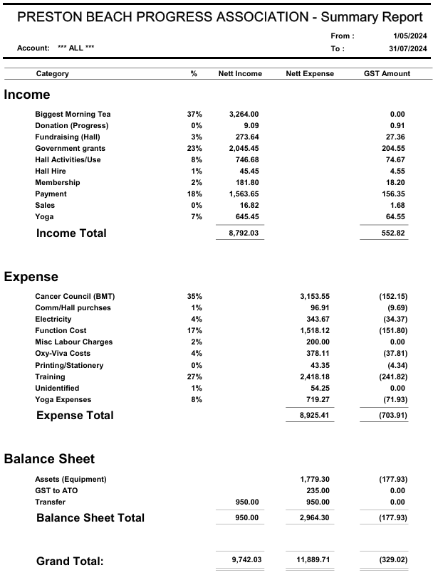

OTHER ORGANISATIONS:
State Government
Robyn Clarke (MLA) advised that the Preston Beach slip lane project on Forrest Highway was still proceeding but had been held up by Western Power’s need to relocate power poles before the road works can commence.

Robyn advised about the electricity rebate to residents. She also advised that the travel allowance available for medical treatment was being increased to 26 cents/km for country residents when travel exceeded 200km.

Robyn advised that she has grant funding of $100K available for application. PBPA to suggest proposals.

Robyn advised that PB would remain within her state electoral boundary, but the federal electoral boundaries had not as yet been set for the next election so could change.

Shire Report
Charlie Clarke (Councillor) advised that the Shire budget was being set for next year and that would release new funding for various issues. The flooding on Syles Road corner was one such works. The flooding on Preston Beach Road has now been fixed.

Charlie talked about the possible relocation of the Pinjarra Road Zoo down to the corner of Forrest Hwy and Preston Beach Road. This is probably a 3 to 4 year timeframe.

Charlie also talked about the funding for the Preston Beach North Road. There had been an article in the local paper about the high ongoing maintenance cost for this road.

Charlie was questioned about when the plan was to be completed and released for the Yalgorup Lakes Nation Park. Charlie is to follow up and advise.

Charlie spoke about the administrative to-and-fro between DFES and the Volunteer Fire Brigades in Waroona. This will (in summary) revert back to the way it has been.

Volunteer Beach Rangers
Noel Dew advised that the last school holidays had been surprisingly quite. The beach front was generally in good condition, but some threats loomed to the south of PB as this was becoming a bit rough.

The appointment of the full-time rangers was proving beneficial and were working well with the volunteer ranges.

The White Weeping Broom plant had now been declared a weed by the Shire. This will be soon publicized and information will be sent out when available. The Shire has cleared a large infestation of this weed in Lake Clifton. There was now proof that rabbits were spreading this weed. It had been agreed with the Shire and the Golf Club that this weed could be dumped on the western side of the 5th fairway for later burning. A map will be prepared and distributed.

Volunteer Fire Brigade
Peter Eastlake advised that the fire brigade has been fairly quiet due to the onset of the wet weather.

The DFES ESO had resigned and the Shire was taking control. John Twaddle had been appointed Chief Fire Officer. This was aligned to the comments from Charlie.

The fire brigade still lacks a light tanker for fighting fires in the dunes.

Golf Club
Peter Allen (President) advised that the Rotary fund raiser last Saturday had raised over $1,000. The first Games Afternoon had been a success, so this will be run monthly. Friday night dinners after golf had recommenced on the first Friday of the month.

Community Garden
John McSwain stated that the garden looks amazing at present due to the rain and the hard work of the members. The monthly markets are continuing and doing well. They have purchased a rotary hoe with the proceeds and were looking forward to putting it to work.

The Community Garden is going to organize a Long Lunch event (date to be confirmed but probably Oct) and they will have a sundowner once the weather improves (probably Sep).

The Community Garden met with the Shire to discuss the possible clearing of the verge on Stables Road.

Police Report
The report for Preston Beach is tabled below.
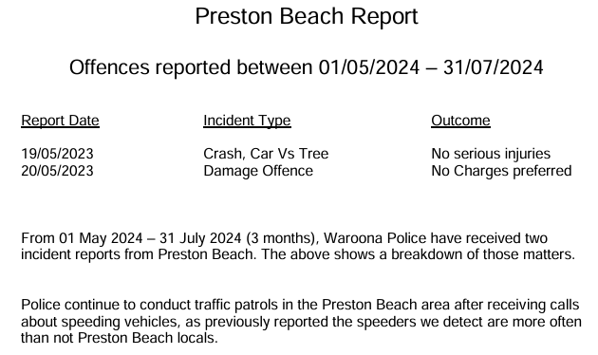
Police non-emergencies Phone: 131 444 or Crime Stoppers: 1 800 333 000
For emergencies Phone: 000

OTHER BUSINESS:
There was no other business raised.

NEXT GENEERAL MEETING:
The next General Meeting of the Preston Beach Progress Association will be held starting at 10:00am on Saturday the 02 November 2024 at the Community Hall.

GENERAL MEETING CLOSED:
There being no further business to discuss, the PBPA GM closed at 12:00 noon.

